# SOPRANO/ALTO VOCAL THEORY TEST: NOTATION

100

**NAME: ___________ Class: ____**

**KNOWLEDGE** 25%

**Complete the following sentences:**

(8) The staff is made up of ________________________and __________________________

(8) The lines and spaces are numbered from ________________using ___________________

(8) The musical alphabet is: ____________________________________________________

**THINKING** 25%



**APPLICATION**  25%

space note over each letter name.

**COMMUNICATION**  25%

Show the sol-fa syllables for the notes on the staff in the key of C:

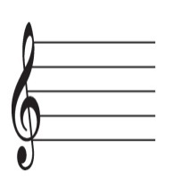  

O

O

O

O

1______________ 2_______________ 3 ______________ 4_______________

Show the notes on the staff for these sol-fa syllables in the key of C:

   

Fa la ti re

5______________ 6_______________ 7______________ 8 _______________